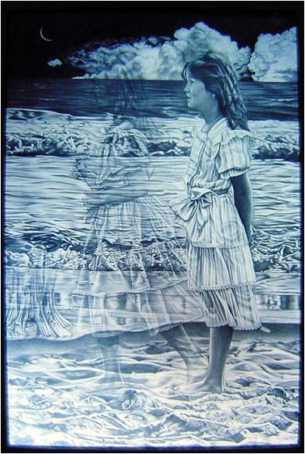BRAIN DONATION PROTOCOL

“As parents, we know that our children and young adults engage with life with everything they’ve got. They would be the first ones to want to find a cure for Rett. And their post mortem brain donation might just provide the key that researchers need to find that cure. Please consider this donation today. Thank you”
Mother of a Rett son whose death initiated the development of this Protocol

“SONYA”
Picture drawn by the artist Petrus Boots
Introduction
When someone you love dies, you will be faced with an overwhelming list of pressing choices to make and things to do. At a time when you may feel emotionally devastated, you will be asked to make quick decisions about matters that you may never have considered before.
One of the questions you may be asked to consider is whether or not you want to make a donation of your child’s brain for research purposes. This brochure is designed to provide you with some basic facts about this type of donation that we hope will help you make an informed decision.

It is essential that tissue(s) be obtained promptly after death in order to obtain the most benefit from the chemical, molecular and neuropathological information.
The donation process is a time-sensitive matter.

The body is treated with dignity and respect, and the wishes of the family are observed at all times. The brain is examined by Dr. Del Bigio, a pediatric neuropathologist, and samples are taken for research, microscopic examination, and comprehensive molecular analysis by Dr. Rastegar at the University of Manitoba.
FREQUENTLY ASKED QUESTIONS
Why is brain tissue donation important?
The purpose of the research is to help develop a better understanding of the molecular genetics and neuropathological features of the human form of Rett Syndrome. This donation process is an opportunity for individuals to help further research towards an eventual treatment and possibly a cure for Rett Syndrome.

What is the role of the next of kin in the donation process?
The next of kin is required to complete the consent forms authorizing a local pathologist to remove the brain. Once completed, the donor’s next of kin is required to fax and/or email a signed copy of a consent form authorizing Dr. Del Bigio to receive this donation.
Who handles organizing the tissue donation?

This is a stepwise process.

Usually the family physician or hospital physician involved at the time of death will notify a local Pathologist who will then give further instructions as to the transfer of the deceased to the Pathologist. There are existing protocols that the Pathologist will follow to take the brain and prepare it for shipment to Dr. Del Bigio of the University of Manitoba who will receive the brain for preparation and provide samples for Dr. Rojgan Rastegar for her ongoing research.

Additional questions about the tissue donation can be directed to the health care provider team, doctor, nurse, or chaplain. They can arrange for you to speak with the appropriate contact person in the pathology department.

Who can give consent for brain tissue donation?
The legally authorized representative (usually, the next of kin) may give consent to donate brain tissue following the death of a donor. If you wish, you can pre-register your loved one in our database.

Are there religious, spiritual, or cultural conflicts?

You may worry that performance of such a donation may conflict with your religious, spiritual, or cultural beliefs. These decisions are always personal. You may want to discuss the decision to make this a donation with other family members and religious or spiritual advisors.

Is there any cost associated with this study?

There are no costs for the family participating in this research study. The study will pay for all expenses involved with this brain donation.
Please note that funeral expenses remain the responsibility of the family.

What happens to your loved one?
The donation procedure does not interfere with the events associated with the funeral. No disfigurement occurs as a result of this procedure. The family can plan an open casket or other traditional funeral arrangements and the donation process will be undetectable. In addition, we will do our best not to interfere with any arrangements the family might have.
How will results obtained with tissue be communicated?
The results obtained will be used in articles for examination by peer review committees before being published in scientific journals. Donor identity will never be revealed and the articles will contain no information permitting the donor to be identified or traced.
The appropriate consent forms necessary to meet the ethical requirements of this research donation are attached to this protocol.

Dr. Marc Del Bigio, MD-PhD Pathologist
marc.delbigio@umanitoba.ca

Dr. Mojgan Rastegar, PhD (Principle Investigator)
mojgan.rastegar@umanitoba.ca, 1(204)290-5203 www.rastegar.biochem.umanitoba.ca

